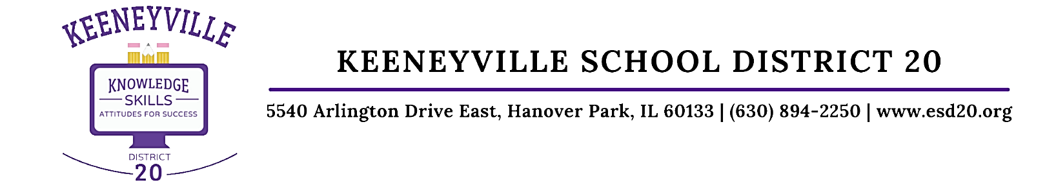
February 28, 2022
Dear Keeneyville District 20 Families,
On Friday, February 25, the CDC changed their COVID-19 guidelines on community transmission levels and mitigations. The CDC’s new recommendations align precautions for schools with those for other community settings. DuPage County’s status changed to Low Transmission, which means that the following preventions steps are recommended by the CDC:
- Stay up to date with COVID-19 vaccinations and booster shots
- Maintain improved ventilation through indoor spaces when possible
- Follow CDC recommendations for isolation and quarantine, including getting tested if you are exposed to COVID-19 or have symptoms of COVID-19
As you know, District 20 updated our mitigation efforts starting last Tuesday, February 22. With state and federal guidelines changing last Friday, effective today District 20 is now able to transition to mask optional on buses. Please take a few moments to review D20’s Mitigations Update (ENGLISH / SPANISH) and/or 2/24/2022 Presentation to the Board, if you have not yet done so. We have also added several Frequently Asked Questions on our district website to provide additional information for families and staff.
We encourage you to complete Parent/Guardian 5Essentials Survey before it closes on March 11. The online survey is completely confidential and is offered in English and Spanish. Please complete a separate survey for each of your children’s schools. Your feedback is very valuable to us as we work collaboratively to provide Keeneyville D20 students with the best education possible!
Sincerely,

Dr. Omar Castillo
Superintendent of Schools
Keeneyville ESD 20

